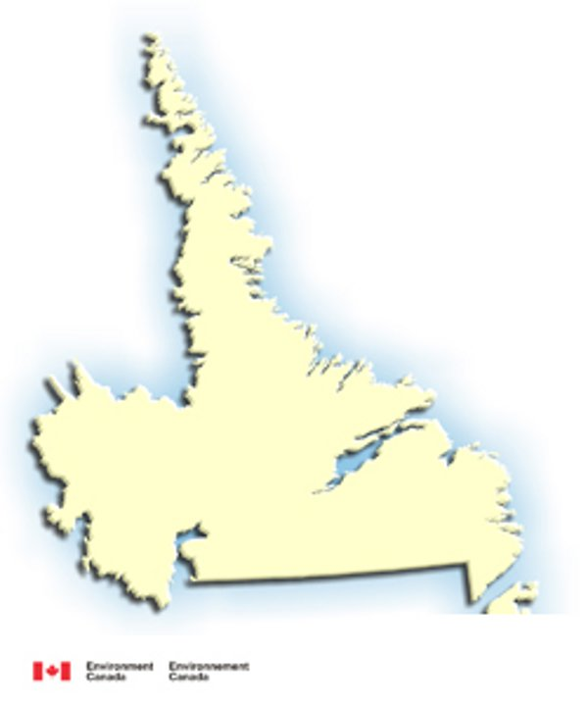
Labrador
Topographical Map
Group Names: ________________________________________________________________________
This Assignment is to create a topographical map of Labrador. This is a map that is focused on the land formations and not on Political or population information. On your web searches you can also call this a relief map or elevation map.

Directions:

- Identify the regions of Labrador, according to elevation: (14 marks)
  - Colour the lowlands , 0 – 100 meters, in dark green
  - Colour the lands from 100 - 300 meters in light green
  - Colour the lands from 300 - 500 meters in tan/yellow
  - Colour the lands from 500 - 700 meters in light brown
  - Colour the lands from 800 - 1000 meters in dark brown
  - Colour the oceans (0 meters) in blue
  - Never colour Quebec!
- Mark these Mountain Ranges using their name and ^^^{^’s} (3 marks)
  - The Kiglapait Mountains
  - The Mealy Mountains
  - The Torngat Mountains

- Mark and label the following topographical features of Labrador (8 marks)
  - The Forteau Barrens
  - The Labrador Plateau
  - The Adlotok River
  - The Churchill River
  - The Eagle River
  - The Fraser River
  - The Naskaupi River
  - The Pardise River
  - The Pinware River

