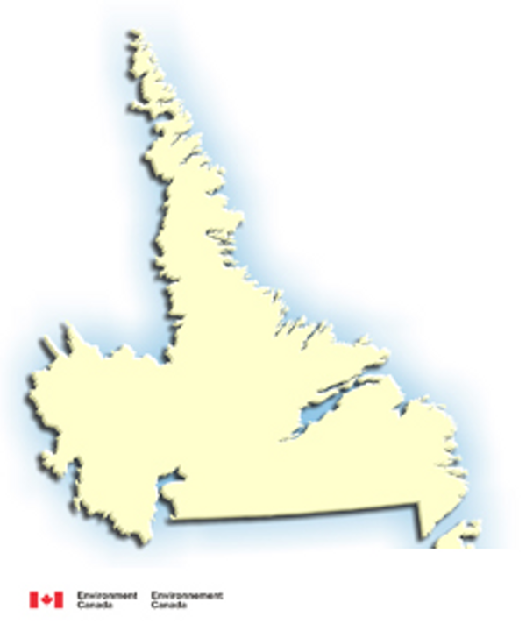
Labrador
Population Map

Labrador Communities
The largest towns in Labrador are listed here:
Labrador City | 9,228 | 8,321
Happy Valley – Goose Bay | 8,438 | 7,921
Wabush | 2,340 | 1,932
Nain | 1,256 | 1,034
L'Anse-au-Loup | 678 | 633
Cartwright | 583 | 507
Hopedale | 564 | 491
North West River | 493 | 456
Port Hope Simpson | 525 | 497
Forteau | 466 | 436

Other communities can be looked up on the Destination Labrador website
http://www.destinationlabrador.com/guide/

Including:

Black Tickle
Capstan Island
Paradise River
Churchill Falls
Cartwright
William’s Harbour
Hebron
St. Lewis
Mary’s Harbour
L’Anse Amour
Makkovik
Mud Lake
Charlottetown
Battle Harbour
Pinsent’s Arm
L’Anse Au Loup
West St. Modeste
Natuashish
Norman’s Bay
Red Bay
Riggolet
Pinware
Postville
Voisey’s Bay

Factor | Labrador | Canada
Male/Female split | 50.3/49.4 | 49.0/51.0
Median age | 34.6 | 37.6
Percent foreign-born. | 8.5% | 18.4%
Aboriginal pop. | 30.9% | 3.3%
Religion - Catholic | 53.8% | 49.6%
Religion - Protestant | 46.0% | 26.2%
Religion - other | 0.3% | 1.6%
No religion | 4.9% | 1.5%
Median income (age 15+) | $20,839 | $22,127
Unemployment rate | 7.6% | 7.4%

