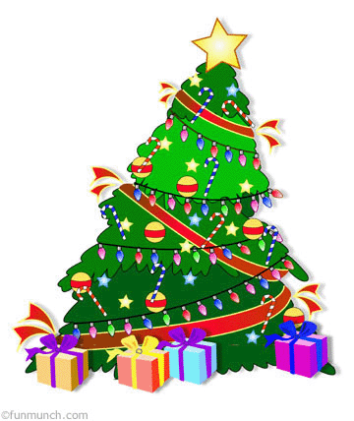
In Search of Christmas
Name: ________________________________ Date: ______________
Find the origins of these well-knows Christmas traditions. Try to find out where the tradition started and what the reason it began was. What important symbols, if any, are shown in each tradition?

Christmas Tradition | Likely origins
Holly

Christmas Tree

Mistletoe

Wreaths

Gift Giving

Gingerbread

Christmas Stocking

Poinsettia

