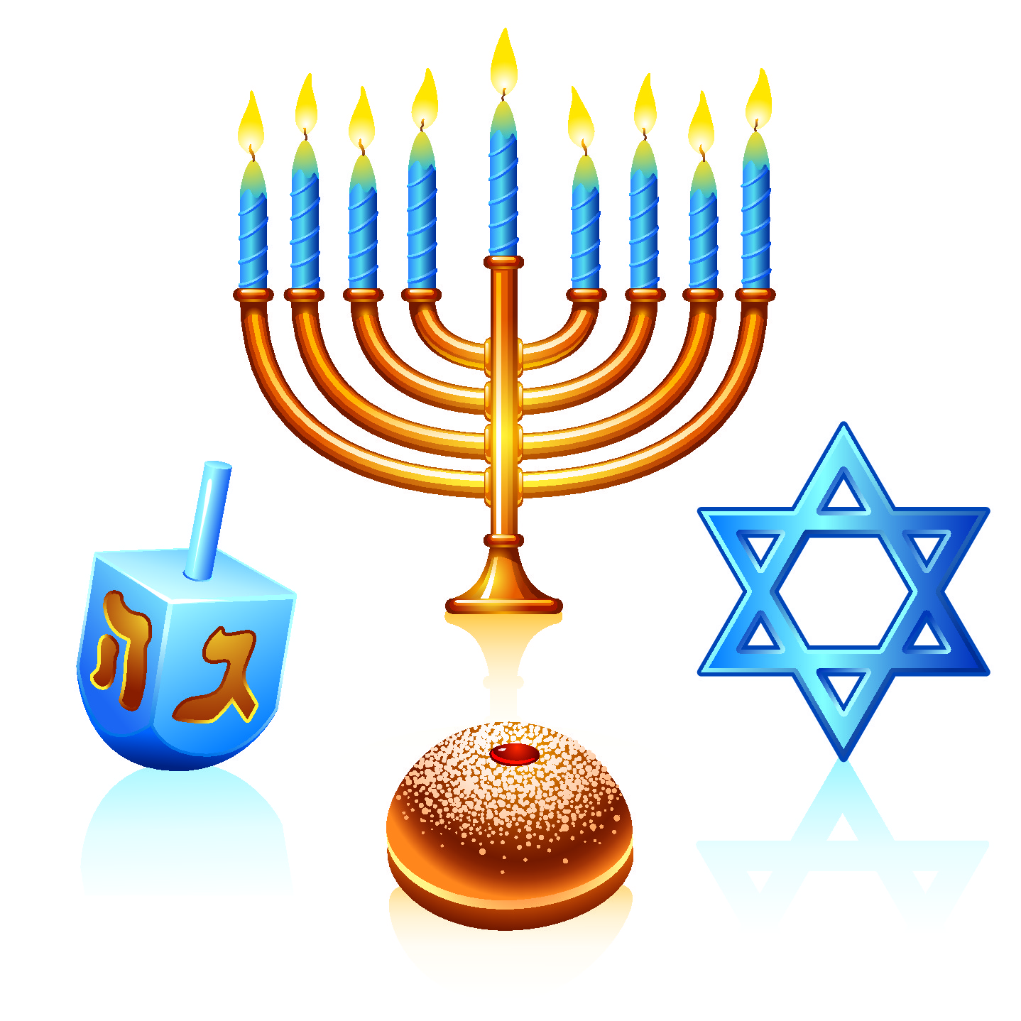
Hanukkah
Name: ________________________________ Date: ______________
Research the origins and traditions that surround the celebration of Hanukkah. Then answer the following questions.

- What religious group celebrates Hanukkah?

- When does Hanukkah happen, and why is it at that time of the year?

- What is the meaning of the word Hanukkah, or is there an English name given to this celebration?

- What historical event is remembered in the Hanukkah celebration? Give the background information for this event.

- What does the Menorah represent during Hanukkah? How do they use it during the Hanukkah week?

- What special traditions are done for the Hanukkah celebrations? Is there a meaning behind each of these traditions? (you can start with any of the objects from the image at the top of the page)

